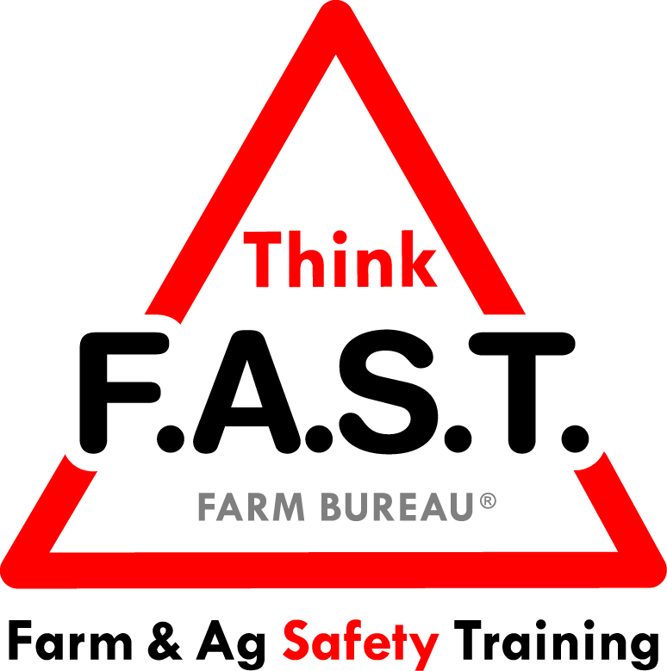

Module 5: Task- Skill Match with Electrical

Objectives:
- The learner will understand that in order to successfully complete a task independently, their skills have to match each step of the task.
- The learner will demonstrate electrical awareness.

Time Required:
- Approximately 40 minutes

Materials & Set-Up:
- Pen/paper – per individual
- Variety of electrical examples, including (but not limited to), electrical PPE, LockOut TagOut equipment, conductors/nonconductors of electricity, etc.

Lesson:

Introduction
- To engage youth, ask them to write down an example of when they were unsuccessful in completing a task because their skills were not at the appropriate level.
- Ask them to write one reflection of how they could have been successful with the task.
  - Example: Given a model, appropriate training, an operator’s manual, etc.
- Remind them that as youth, and even as adults, our skills have to match the task in order to be successful and safe. Discuss options for improving task-skill match with the following prompts:
  - What could you do to be more successful at a task that doesn’t match your skill set?
  - Who could you ask for help?”
- Preview that today’s focus is on electrical safety. Being able to recognize electrical hazards and assess whether your skills match the electrical task at hand is critical for safety.

Suggested Skill Building Activities:
*Note: Instructor may modify for time and regionally-appropriate content, as long as safety and core skills are adequately addressed.

- Assessing Your Skill Set
  - Have several examples of complex skills in mind for the activity:
    - Examples: Building a website, teaching a swimming lesson to a small child, baking bread, etc.
  - Have youth stand, and label one end of the classroom/area as “I can do this task,” and the other end as “I can’t do this task.”
  - Ask youth to arrange themselves on this “Task Continuum” according to their perceived skill set, as you call out the first task example.
  - Participants will stay put as you ask various thought provoking questions, such as:
    - Why did you put yourself at this place on the continuum?
    - What skills do you have that made you pick this spot?”
  - Read the next example, and have youth shuffle on the continuum based on their skill sets.
  - Repeat discussion questions and further examples as time allows.

Core skill: We have to be able to analyze our skills and whether they match the task at hand.
Indicators of activity success:
- Through active participation, learners are engaged in thoughtful responses to the task-skill match activity.

- Electricity is All Around
  - Have youth gather around the electrical items. Through a brief presentation, explain the items and their significance to electricity and electrical safety.
  - Point out relevant examples of electricity within the current environment or a known environment for the youth.

Core skill: Understanding that electricity is all around us in various forms.
Indicators of activity success:
- Through active participation, learners demonstrate knowledge or desire to learn about forms of electricity and electrical conduction.

- Scavenger Hunt
  - Ask youth to pair up or work in small groups. Give each group a piece of paper and pen.
  - Have each group write down the following three items on their sheet (may add more at instructor discretion):
    - Example of electricity
    - A good conductor of electricity
    - Something that does not conduct electricity
  - Clearly define the game area and time limit. Send youth on a scavenger hunt for their items. When they find the item, they must either take a picture or write it down on their paper. The first team back to the starting point wins!
  - Wrap up the game with show and share and discussion of items that the groups found.

Core skill: We have to be able to recognize sources of electricity around us and understand what does and does not conduct electricity.
Indicators of activity success:
- Through active participation, learners demonstrate knowledge or desire to learn about electricity and conductors.

Reflection Questions
- To close out the lesson, ask youth the following questions, and allow for individual or group discussion:
  - Why is electricity referred to as the “silent killer?”
  - What can you do to increase your skill set or become safer around electricity?

Challenge
- Electricity is essential to our daily life, at home, work, and school. We often fail to give electricity the respect that it deserves, and its ability to seriously injure and kill. The next time you simply plug in an electrical cord, think about the power in electricity, and how you can be more aware of the danger.

Additional Resources:
- National Fire Protection Association - Safety Tips: http://www.nfpa.org/public-education/by-topic/top-causes-of-fire/electrical/electrical-safety-in-the-home/electrical-safety-tips

- Linn County Rural Electric Cooperative – Electrical Safety on the Farm: https://www.linncountyrec.com/safety-and-education/farm-safety/

