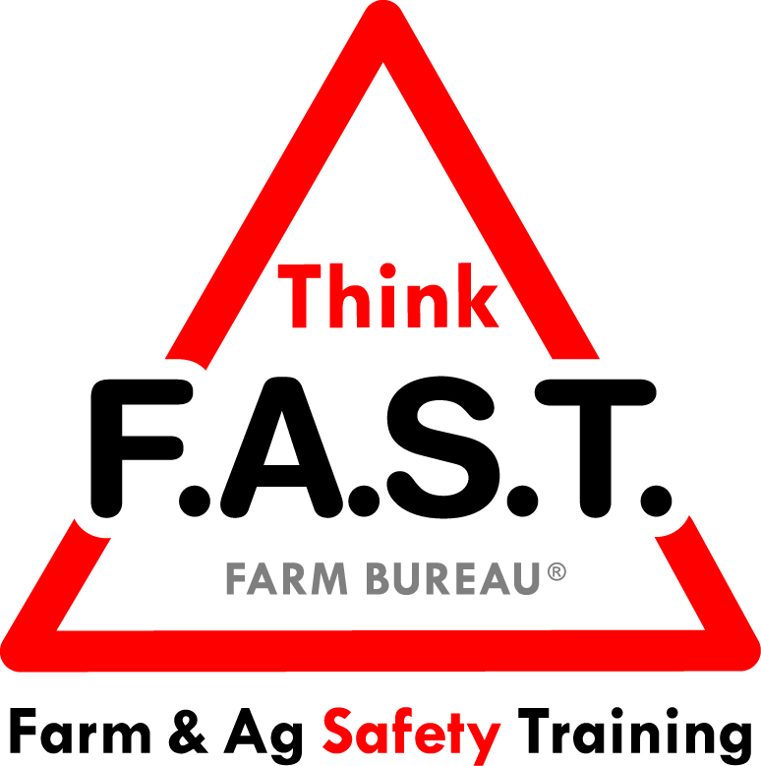

Module 6: Decision Making with Manual Labor

Objectives:
- The learner will understand that decision making is a personal choice that can be simple or complex, and lead to both positive and negative outcomes.
- The learner will demonstrate appropriate manual labor awareness and age-appropriate skills.

Time Required:
- Approximately 40 minutes

Materials & Set-Up:
- Pen/paper – per individual
- Create a short scenario that reflects local agriculture and manual labor tasks (for Suggested Skill Building Activities, #2)
- Appropriate research and instructor ability for lifting techniques (See Additional Resources section)
- Variety of items that represent opportunities for manual labor appropriate to your region/area.
  - Examples: Bags of feed/seed, produce crates, tools such as a digging iron, irrigation pipe, etc.
- Optional: Poster or notecards with the following acronym for reference
  - (F) Factors
  - (A) Ability
  - (S) Safety
  - (T) Time

Lesson:

Introduction
- To engage youth, ask them to think about a hard decision that they had to make recently.
- Ask them to write down one positive outcome of that decision and one negative outcome of that decision. Allowing sharing as appropriate.
- Remind them that as youth, and even as adults, the decisions that we make can have far-reaching consequences – both positive and negative.
- Preview that today’s focus is on manual labor tasks. Being able to make an appropriate decision regarding whether or not to engage in a manual labor task and how to do it appropriately can go a long way for injury prevention.

Suggested Skill Building Activities:
*Note: Instructor may modify for time and regionally-appropriate content, as long as safety and core skills are adequately addressed.

- Decision Making
  - Break class into three groups. Give each group a different scenario to write on their team paper:
    - Checking on the animals
    - Performing maintenance on equipment
    - Interacting with co-workers or family
  - Ask groups to take 2-4 minutes to discuss and write about how they would make decisions within their scenario in both a routine situation and an emergency situation.
  - Allow groups to share their top points from both their routine and emergency situations.

Core skill: We have to understand that our decision making ability is not stagnant. It requires thought that is dependent on the environment and other factors.
Indicators of activity success:
- Through active participation, learners are engaged in thoughtful responses to the decision making activity.

- Working FAST!
  - Have youth gather around the manual labor items. Remind them that when thinking about performing manual labor, they need to consider FAST: (provide the poster or notecards for reference)
    - (F) Factors: There are many different environments and considerations for manual labor
    - (A) Ability: Does our strength and knowledge match the task?
    - (S) Safety: Is it safe to do this task in this environment / with this equipment?
    - (T) Time: Do I have the proper time to do the task in a safe, unhurried way?
  - Using a scenario that reflects local agriculture and manual labor, have youth discuss FAST in relation to the scenario. Discussion questions may sound like:
    - What factors do we need to consider with this task?
    - Would those change if the task was done in a different environment?
    - How does your ability (and the ability of those around you) affect the task?
    - What can you do in this scenario with regards to safety?
    - How does time affect this task?

Core skill: Understanding that tasks require decision making to ensure safety and success.
Indicators of activity success:
- Through active participation, learners demonstrate knowledge or desire to learn about decision making skills with regards to manual labor.

- Ability Match
  - Ask youth to pair up based on similar size and/or ability.
  - Model appropriate lifting technique for a common item. Demonstrate both individual lifts and partner lifts (as appropriate).
  - Youth will practice proper lifting techniques under close supervision, with appropriate weight. Offer feedback.

Core skill: We need to be able to lift items properly to reduce our risk of injury.
Indicators of activity success:
- Through active participation, learners demonstrate appropriate lifting techniques.

Reflection Questions
- To close out the lesson, ask youth the following questions, and allow for individual or group discussion:
  - How do our decisions affect those around us?
  - What do you want to demonstrate to others through your decision making?
  - How can you think FAST about your personal tasks?

Challenge
- As youth, your brain is still developing and dealing with lots of change. Youth often have the ability to make decision like adults, but let others influence their decision-making process. The next time you’re faced with a major decision, use the FAST model to think about what is the best choice for you. Don’t let others influence your decision-making process too much, and allow yourself adequate time to think things through!

Additional Resources:
- OSHA Material Handling: Heavy Lifting Tips: https://www.osha.gov/SLTC/etools/electricalcontractors/materials/heavy.html
- North American Guidelines for Children’s Agricultural Tasks (see section on “Manual Labor”): http://www.nagcat.org/nagcat/?page=nagcat_guidelines_posters

